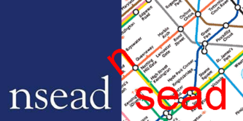

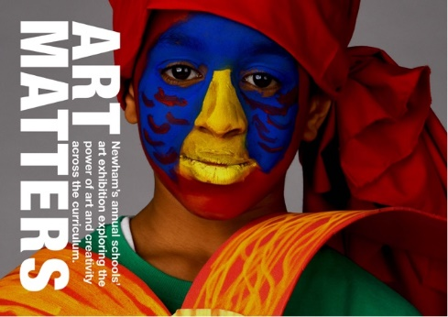

ART MATTERS TEACHERS TRAINING EVENT
Featuring Artist Chila Burman

ART MATTERS in collaboration with the University of the Arts, London, University of East London and NSEAD/SEAD(South East Art & Design) will be hosting a FREE teachers training event on Saturday 6th July 10.30am-3.30pm
Address: The University of East London, Docklands Campus, AVA Building, University Way, London, E16 2RD (Link: https://goo.gl/maps/42m9wm91bDF2 )
For information about the previous Art Matters Exhibition and Venue, see:
www.artmatterslondon.com

The annual East London Schools Art Exhibition is supported by UEL and UAL
Aims of the session:
- Opportunity to view the annual East London Schools Exhibition ‘Art Matters’
- Explore matters related to the Exhibition and implications for learning and teaching
- Engage in practical drawing workshop run by UAL/LCF
- Artist talk from Chila Kumari Burman
- SEAD action planning

Programme:
We will be based in Knowledge Dock and the ADI studio.

10.30 Welcome / Outline of the day and introduction to the show

10.50 View ‘Art Matters’ Exhibition
- Teachers are welcome to bring and use sketchbooks, drawing implements, camera phones, notation to record their observations and thinking

11.45 Reconvene in studio for plenary session

12.00-12.45 Lunch (A light lunch will be provided, please bring your own lunch if you have specific dietary requirements)

12.45-2.15 practical drawing workshop led by UAL /LCF
2.15-3.00 Talk by Artist Dr. Chila Kumari Burman
- Dr. Chila Kumari Burman is an iconic British artist. A significant figure in the Black British Art movement of the 1980s. Burman was one of the first British Asian female artists to have a monograph written about her work: Lynda Nead’s, Chila Kumari Burman: Beyond Two Cultures (1995) and a second monograph by Nead was published in 2012. In 2018, Burman received an honorary doctorate from University of the Arts London for her outstanding contributions to the Creative Industries.
3.00-3.30 SEAD Meeting-development and action plan

This Network Meeting is due to start at 10.30am and will run until 3.00pm.

You are welcome to:

- Learn from each other – Please bring information to share or network/distribute.

- Engage with the exhibition – you are encouraged to bring a sketchpad, drawing materials and camera/camera phone for the exhibition activity.

To register for this event please visit…...

For more information about the Art Matters Exhibition or venue contact Ashia or Catherine at: ashia.oozeer@plashet.newham.sch.uk or catherinemcgill56@gmail.com

Please provide details of vehicle registration numbers if arriving by car

We look forward to seeing you at the Meeting.

Ashia Oozeer, Catherine McGill, Ian Thompson, Ged Gast, Charlie Salter

